**IS187x - BLEDK3 v1.00 Auto Pattern Tool**

**User Guide**

Table of Contents

1 Overview 3

2 Hardware Environment 4

2.1 Environment Setup 4

2.2 BLEDK3 EVB Outlook 4

2.3 GPIO Configuration 5

3 Software Outlook 5

3.1 Settings 5

3.2 Raw Data Page 7

3.3 Pass Key Page 9

3.3.1 Passkey Entry 9

3.3.2 Passkey Confirm 10

3.4 Configure Mode Page 11

3.4.1 Enter Configure Mode 11

3.4.2 Configure Mode Control 12

3.4.3 Leave Configure Mode 13

3.5 ADV/SR Page 14

4 Revision History 16

# Overview

This document describes how to use the emulation tool of BLEDK3 with auto pattern settings.

# Hardware Environment

## Environment Setup

BLEDK3 v0.9 auto pattern test tool is designed to be installed in Microsoft Windows based PC to act as an MCU emulator to transmit and receive data through USB interface during Bluetooth LE profiles communications with a cellular phone.

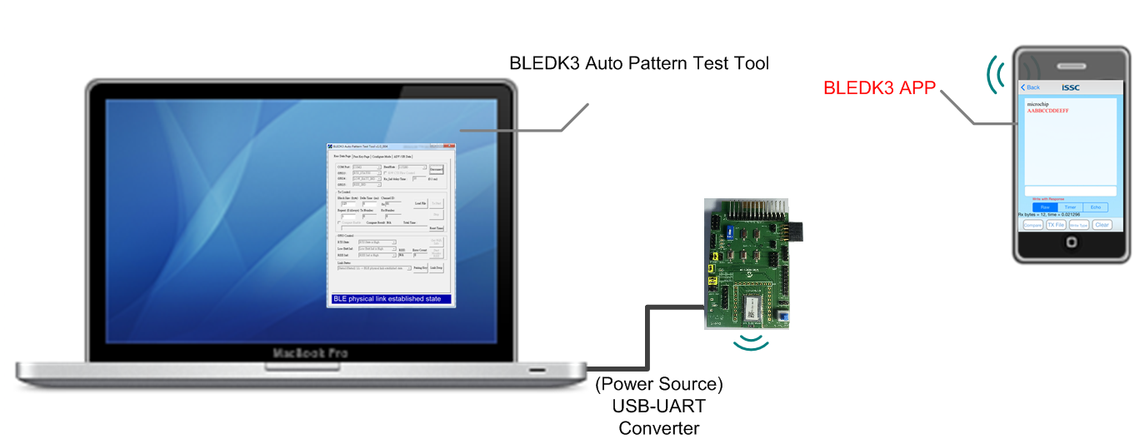

Figure 2.1 BLEDK3 Environment Setup

## BLEDK3 EVB Outlook

The GPIOs of [JP10] that are controlled by PC tool must connect to corresponding pins of BLEDK3 before using this tool. The section 2.3 describes how to map the GPIOs between [JP10] and [CN1~CN3].

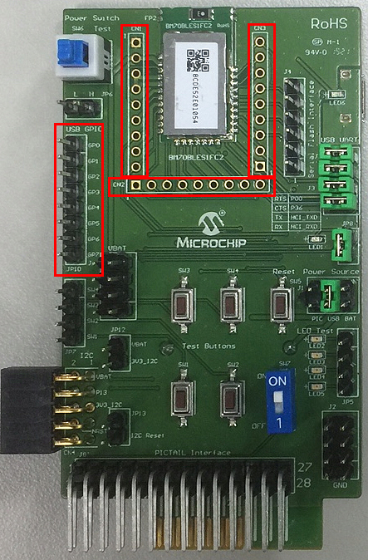

Figure 2.2 BLEDK3 EVB

[CN1~CN3] - Available GPIO pins of BM70BLES1FC2 EVB

[JP10] - 8 pin GPIOs, connect it with I/O pin of [CN1~CN3].

## GPIO Configuration

This section describes how to wire each GPIO pin of JP21 to BLEDK3.

|  |  |  |
| --- | --- | --- |
| Pin no. | Property(indicate what “M” and “O” means) | Description |
| GPIO 0 | M | Connect to UART_RX_IND pin of BLEDK3(Default:P33, can be configured by UI tool) |
| GPIO 1 | M | Connect to LINK_DROP pin of BLEDK3 (Default: P32, can be configured by UI tool) |
| GPIO 2 | M | Connect to PAIRING_KEY pin of BLEDK3(Default: P34, can be configured by UI tool) |
| GPIO 3 | O | It is adjustable in the tool. Several features described later can be chose to control or monitor. Connect to a pin of BLEDK3 upon the settings of tool and UI configuration. |
| GPIO 4 | O | It is adjustable in the tool. Several features described later can be chose to control or monitor. Connect to a pin of BLEDK3 upon the settings of tool and UI configuration. |
| GPIO 5 | O | It is adjustable in the tool. Several features described later can be chose to control or monitor. Connect to a pin of BLEDK3 upon the settings of tool and UI configuration. |
| GPIO 6 | M | Connect to BLEDK_STATUS_IND (P11) |
| GPIO 7 | M | Connect to BLEDK_STATUS2_IND (P10) |

There are several optional features for GPIO 3 to GPIO 5 including:

1. Low Battery Indicator: indicate battery low or normal (High status means low battery).
2. RSSI Indicator: Link quality indicator, normal or weak (High status means low quality).
3. UART RTS (Default: BLEDK3_P36): RTS status (High status means flow stop).

# Software Outlook

## Settings

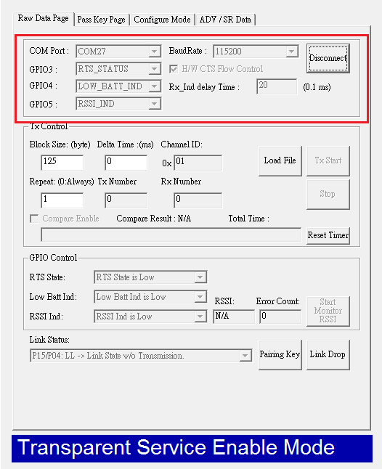

Figure 3.1 Tool settings

[COM Port]: The settings of COM port connecting with BLEDK3.

[GPIO3][GPIO4][GPIO5]: Adjustable GPIOs.

[H/W CTS Flow Control]: Enable/disable UART flow control of MCP2200.

[Rx_Ind delay Time]: Adjust the delay time of Rx_IND before transmitting data to ensure BLEDK3 is ready to receive UART data. The time may be different upon the performance of computers.

## Raw Data Page

This page consists of some functions to emulate MCU to test the stability of BLEDK3 mainly, such as data transmission, GPIO indication and link status.



Figure 3.2 Raw data page view

1. **Tx Control**

[Load File]: Load a text file for transmission or received data comparison.

[Block Size]: The size of UART data block.

[Delta Time]: The delay time between data blocks.

[Channel ID]: it is non-used at present.

[Repeat]: The repeated round times of data file transmission. (Always repeat if this parameter set to 0).

[Tx Number]: Amount of transmitted data.

[Rx Number]: Amount of received data.

[Tx Start]: Start to transmit the file.

[Stop]: Stop data transfer.

[Compare Enable]: Enable/disable the Compare function. The comparison will be triggered while no more incoming data for 3 seconds.

[Reset Timer]: Reset the timer count of receiving data.

1. **GPIO Control**

[RTS State]: Show the RTS status. (The feature enabled by the selection of GPIO3~5)

[Low Batt Ind]: Low battery indication. (The feature enabled by the selection of GPIO3~5)

[RSSI Ind]: RF signal strength indication. (The feature enabled by the selection of GPIO3~5)

[Start Monitor RSSI]: This button is no use in BLEDK3.

1. **Link Status**

[Link Status]: Monitor the link status of BLEDK3 by GPIOs.

[Pairing Key]: Force BLEDK3 to drop connection (if a connection existing) and enter Standby mode once this button is pressed.

[Link Drop]: Force BLEDK3 drop connection and enter shutdown mode once this button is pressed.

## Pass Key Page

This page is used in pairing process between BLEDK3 and remote device. It is only for Passkey Entry and Passkey Confirm upon the setting of pairing method of BLEDK3.

### Passkey Entry

When BLEDK3 needs passkey in paring process, the tool pops up a notification and then have a numeric keyboard for users’ input. When finishing typing the passkey displayed on the phone, pressing Enter button is must. Notice that there is a valid period of time for passkey input, users need complete it within a timeout: 30 seconds.

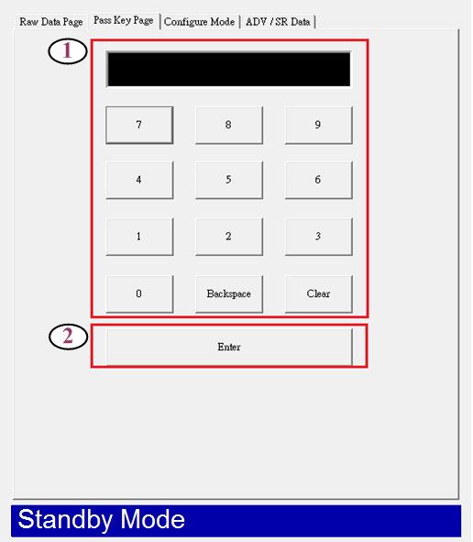

Figure 3.3.1 Enter passkey

### Passkey Confirm

In passkey confirm method, there is a little difference between BT3.0 and BT 4.0.

In BT3.0 pairing, it is numeric comparison, users should compare the passkey displayed on the phone and tool, and then press Yes or No. And in BT4.0, the tool will show passkey and Yes/No selection, users need to type the passkey on the phone and press Yes in tool side.

.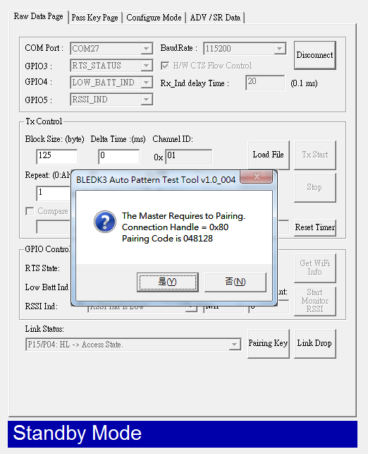

Figure 3.3.2 Passkey confirm

## Configure Mode Page

### Enter Configure Mode

When BLEDK3 with auto pattern settings starts up, it may enter Configure Mode upon UI setting. BLEDK3 sends a message through UART after entering Configure Mode, and then the tool pop up a notification as Figure 3.4.1.

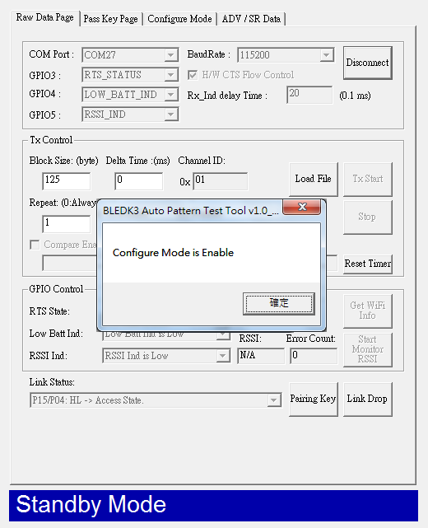

Figure 3.4.1 Enter configure mode

### Configure Mode Control

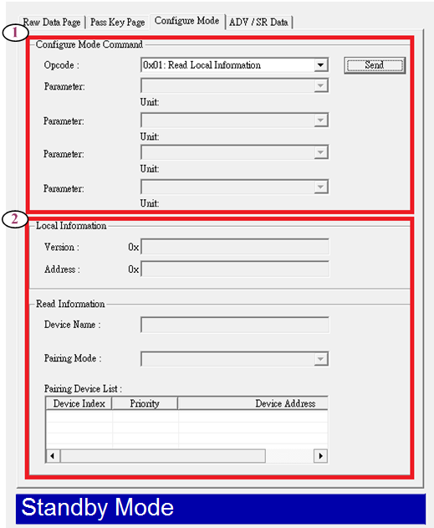

Figure 3.4.2 Configure mode page view

1. **Command configure**

[Opcode]: The command controller. More detail for commands please refer to **BLEDK3SPP and BM79BLETR Command Set** document

1. **Command Response**

[Version]: Version number of BLEDK3, the response of the command (**0x01: Read Local Information**).

[Address]:BT address of BLEDK3, the response of the command (**0x07: Read Device Name**)

[Device Name]: Device name of BLEDK3,the response of the command (**0x50: Read PIN Code**)

[PIN Code]: PIN code setting of BLEDK3 used in pairing process if secure simple pairing is disabled, the response of the command (**0x0A: Read Pairing Mode Setting**)

[Pairing Device List]: Paired record in BLEDK3, the response of the command (**0x0C: Read All Paired Device Information**)

### Leave Configure Mode

Force BLEDK3 to leave “Configure Mode” by sending the command (**0x52: Leave Configure Mode**).

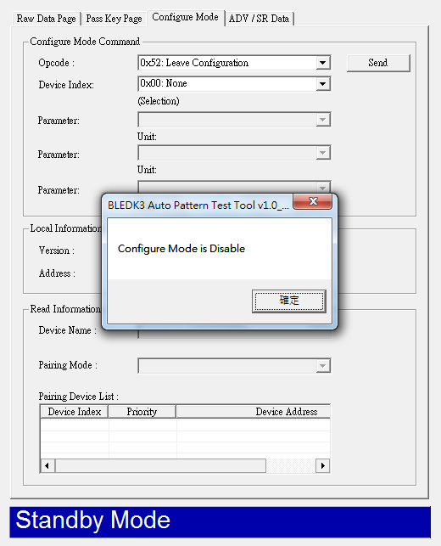

Figure 3.4.3 Leave configuration mode

## ADV/SR Page

Besides **Configure Mode** page, this page is also only used in Configure Mode.

Users can edit the data in advertise or scan response packet, such as **Service UUID**, **Local name**, **Manufacture Data** and so on.

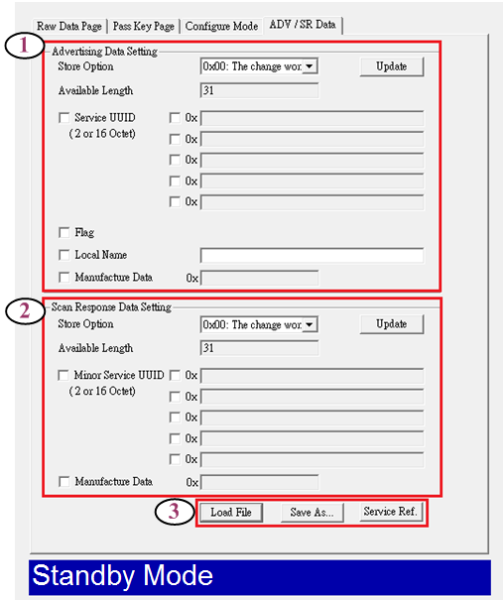

Figure 3.5 ADV/SR page view

1. **Advertising Data Setting:**

[Store Option] : The store option of advertising data, user can choose change store to EEPROM or not.

[Update] : To update the advertising data by sending the command(**0x11: Write ADV Data**).

1. **Scan Response Data Setting**

[Store Option] : The store option of scan response data, user can choose change store to EEPROM or not.

[Update] : To update the scan response data by sending then command(**0x12: Write Scan Response Data**).

1. **File Access and service reference.**

[Load File] : Load a ADV / SR data file.

[Save As..] : Save the ADV / SR data as a file.

[Service Ref.] : To visit the services reference on the Bluetooth SIG official website.

# Revision History

|  |  |  |
| --- | --- | --- |
| Version | Date | History |
| D006R01 | 2015/03/31 | First Edition of BLEDK3 Auto Pattern Tool User Guide |